**SPAM REVIEW DETECTION USING LINGUSTIC & BEHAVIORAL METHOD**

**SOFTWARE REQUIREMENTS SPECIFICATION**

**INTRODUCTION**

The requirements are grouped by their stakeholders, and functional and non-functional requirements are separated.

**SCOPE**

The aim of this work is to develop an Spam Review Detection(SRD) model adapting a vast set of behavioral and linguistic features on large-scale real-world dataset.

**SYSTEM ENVIRONMENT:**

Spam Review Detection Model environment consists of 1 active Actor and Co-operating system. The user access the platform using internet. Any active user can login through the system using his saved credentials otherwise by registering himself to the system.

**PURPOSE OF THE PROJECT**

Nowadays the World Wide Web (WWW) has become the main source for individuals to express themselves. People can easily share their views about any product or service by using e-commerce sites, forums and blogs. Everybody on the web is now acknowledging the importance of these online reviews for both customers and vendors. Most people read reviews about products and services before buying them. Vendors can also design their future production or marketing strategies based on these reviews .Our project helps to identify spam reviews given by the users to avoid promotion and demotion of the product.

**STAKEHOLDERS**

|  |  |
| --- | --- |
| U | User |
| A | Admin |

**Functional Requirements of User**

|  |  |
| --- | --- |
| FR1 | The system must enable user to register themselves by providing their personal details. |
| FR2 | The system must allow users to login through their username and password after registering. |
| FR3 | The system must allow users to reset their profile. |
| FR4 | The system must provide the spam score to the user |
| FR5 | The system must show whether the review is spam or not |

**Functional Requirements of Admin**

|  |  |
| --- | --- |
| FR6 | The system must allow Admin to login with valid credentials. |
| FR7 | The System must allow Admin to access the database of the application. |
| FR8 | The system must allow Admin to add/remove/block users profile. |
| FR9 | The system must provide admin all control over credentials details of users. |

**Non-Functional Requirements for User and Admin**

|  |  |
| --- | --- |
| NF1 | **Usability**  The system is designed with completely automated process hence there is no or less user intervention. |
| NF2 | **Reliability**  The system is more reliable because of the qualities that are inherited from the chosen platform Anaconda. The code built by using python is more reliable. |
| NF3 | **Performance**  This system is developing in the high level languages and using the advanced front-end and back-end technologies it will give response to the end user on client system with in very less time. |
| NF4 | **Supportability**  The system is designed to be the cross platform supportable. |
| NF5 | **Security**  The System shall provide security to user’s data. |

**USE CASE DIAGRAM**

**Description:** This diagram describes the actions performed by the actors .The user gives the input review and get the spam result and spam score(as pie chart).

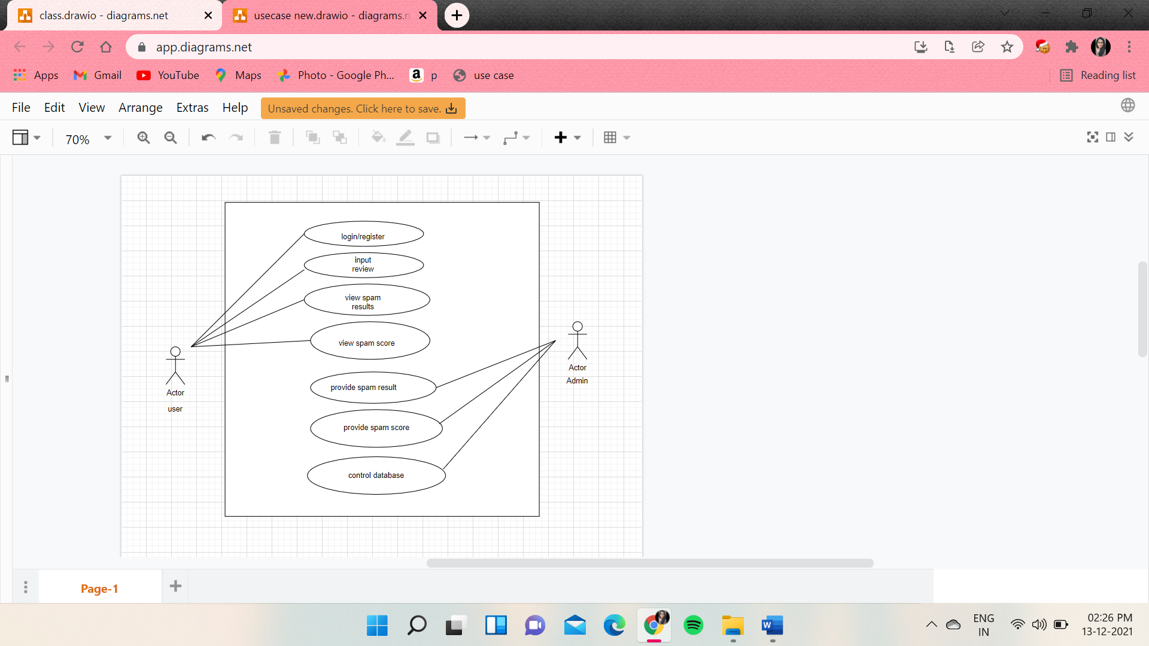

1.LOGIN/REGISTER

USER

Login/Register

**Brief Description**

The user should provide the accurate credentials to login. If the account does not exists the user should register.

**Initial Step-By-Step Description**

Before, this use case is initiated, the user has already access to internet and opened the website

1. The user clicks on Login button.
2. The user enters the username in the space provided.
3. The user enters the respective password.
4. If the user forgets his/her password, they click on forgot password option.
5. The user clicks on submit button to login successfully.

|  |  |
| --- | --- |
| **Use Case Name** | Login/Register |
| **XRef** |  |
| **Trigger** | The User enters the credentials to login/register |
| **Precondition** | The User should initially have access to the website |
| **Basic Path** | User login through the website by providing his/her credentials. |
| **Alternative Paths** | The user should create an account if doesn’t exists |
| **Postcondition** | The User is directed to the input grid window |
| **Exception Paths** | The User may abandon the operation at any time. |
| **Other** | None |

2.INPUT REVIEW

USER

Input Review

**Brief Description**

The user has access to the website and can provide the input review to check the review is spam or not.

**Initial Step-By-Step Description**

Before this use case is initiated the user is already login to the website.

1. The user sees the space provided to write the review.
2. The user enters his/her review in the input grid.
3. The user clicks on spam result button.

|  |  |
| --- | --- |
| **Use Case Name** | Input Review |
| **XRef** |  |
| **Trigger** | The user should provide the review and click submit button |
| **Precondition** | The user should login with correct credentials and have access to the online website |
| **Basic Path** | User enter the correct credentials and write the input review in the grid |
| **Alternative Paths** | User may logout if not |
| **Postcondition** | The system displays the review is spam or not and user can also get the spam score by clicking the spam score button. |
| **Exception Paths** | The User may abandon the operation at any time. |
| **Other** |  |

3.VIEW SPAM RESULT

USER

View Spam Result

**Brief Description**

The spam results can be checked by user after entering the correct input and clicking the spam result button

**Initial Step-By-Step Description**

Before this use case in initiated the user is already provided the review in the input grid.

1. The user can view the result of the provided review.
2. The user understands if the provided review is spam or non-spam review.

|  |  |
| --- | --- |
| **Use Case Name** | View Spam Result |
| **XRef** |  |
| **Trigger** | Submitting the input review by the user in the provided input grid |
| **Precondition** | The user initially should the review in the input grid |
| **Basic Path** | After submitting the system displays the spam result |
| **Alternative Paths** | The user can also get the spam score of the provided input review |
| **Postcondition** | The user can be redirected to the input grid window or can view the spam score. |
| **Exception Paths** | The attempt may be abandoned at any time. |
| **Other** | None |

1. VIEW SPAM SCORE

USER

View Spam Score

**Brief Description**

The user gets the spam score in the form of pie-cart by clicking the spam score button.

**Initial Step-By-Step Description**

Before this use case in initiated the user is already provided the review in the input grid.

1. The user clicks on view spam score button.
2. Pie-chart is displayed, which indicates the percentage of spam the review is.
3. User can logout of the website.

|  |  |
| --- | --- |
| **Use Case Name** | View Spam Score |
| **XRef** |  |
| **Trigger** | The user should click the spam score button |
| **Precondition** | The user should provide the input review |
| **Basic Path** | The user gets to view the pie-chart after submitting |
| **Alternative Paths** | The activity is completed ,user can go to the home page |
| **Postcondition** | User can get the spam score later redirected to the input grid page or user may logout. |
| **Exception Paths** | The attempt may be abandoned at any time. |
| **Other** | None |

5.PROVIDE SPAM RESULT

**Brief Description**

After providing the input review by user the system provides the spam result.

**Initial Step-By-Step Description**

Before this use case in initiated the admin receives the review from the input grid provided by the user

1.The admin provides the result of the provided review.

USER

Provide Spam result

|  |  |
| --- | --- |
| **Use Case Name** | Provide Spam Result |
| **XRef** |  |
| **Trigger** | The admin receives the data from the user & provide the spam result |
| **Precondition** | The user initially should provide the review in the input grid |
| **Basic Path** | The admin sends the input review to the algorithm |
| **Alternative Paths** | The admin can also provide the spam score |
| **Postcondition** | The admin waits for another new input review to provide the spam result. |
| **Exception Paths** | The attempt may be abandoned at any time. |
| **Other** | None |

6.PROVIDE SPAM SCORE

**Brief Description**

The system provides the spam score after the user clicks the spam score button.

**Initial Step-By-Step Description**

Before this use case in initiated the admin is already provided with the review from the input grid.

1.Pie-chart is displayed, which indicates the percentage of spam the review is.

2.Admin can terminate the process if the input is not provided by the user .

USER

Provide Spam Score

|  |  |
| --- | --- |
| **Use Case Name** | Provide Spam Score |
| **XRef** |  |
| **Trigger** | The admin receives the data from the user & provide the spam score |
| **Precondition** | The user initially should provide the review in the input grid |
| **Basic Path** | The admin sends the input review to the algorithm |
| **Alternative Paths** | The process can be terminated if the input is incorrect |
| **Postcondition** | The admin waits for another new input review to provide the spam score |
| **Exception Paths** | The attempt may be abandoned at any time. |
| **Other** | None |

**SYSTEM REQUIREMENTS:**

**Hardware Requirements:**

Processor : Intel Core 5 (I5)

RAM : 8 GB

Monitor:14*11 inches

Memory :1 TB

Drive Type: Solid State Drive(SSD)

**Software Requirements:**

Operating System :Windows 11

Web Framework :Flak

Frontend : Java Servlet Pages(JSP),HTML,CSS, Java Script

Database : My SQL

**Modules Identification:**

1.Data Preprocessing

2.Model Selection

3.Training the Model

4.Analyze and Prediction

5.Accuracy on Test Data

6.Saving the Trained Model